SEC Form 4

FORM 4

Check this box if no longer subject to Section 16. Form 4 or Form 5 obligations may continue. See Instruction 1(b).

Check this box to indicate that a transaction was made pursuant to a contract, instruction or written plan for the purchase or sale of equity securities of the issuer that is intended to satisfy the affirmative defense conditions of Rule 10b5-1(c). See Instruction 10.

UNITED STATES SECURITIES AND EXCHANGE COMMISSION
Washington, D.C. 20549
Washington, D.C. 20549 |  | OMB APPROVAL
STATEMENT OF CHANGES IN BENEFICIAL OWNERSHIP
STATEMENT OF CHANGES IN BENEFICIAL OWNERSHIP |  | OMB Number: | 3235-0287
 |  | Estimated average burden
Filed pursuant to Section 16(a) of the Securities Exchange Act of 1934 |  | hours per response: | 0.5
or Section 30(h) of the Investment Company Act of 1940
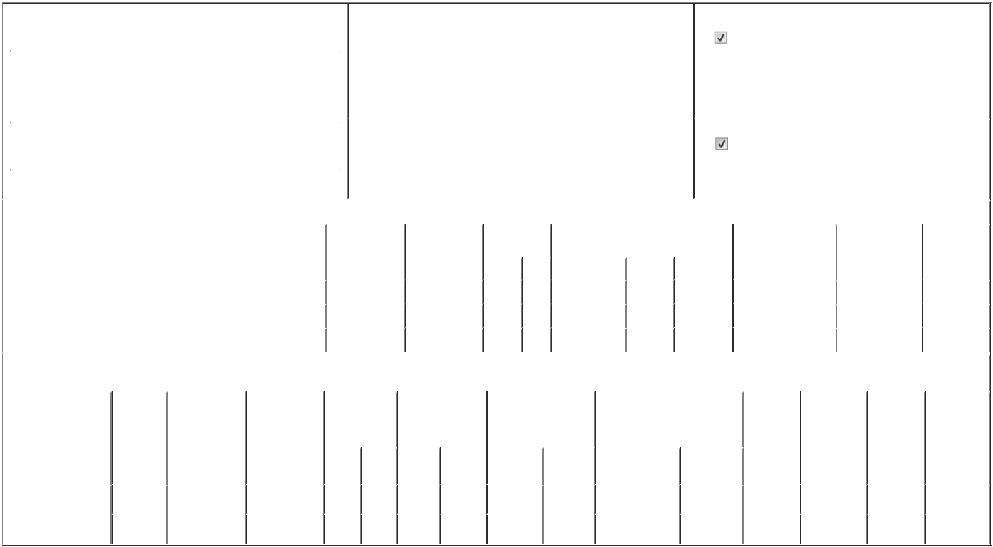

 | 1. Name and Address of Reporting Person* |  |  |  |  |  |  |  |  | 2. Issuer Name and Ticker or Trading Symbol |  |  |  |  |  |  |  |  |  | 5. Relationship of Reporting Person(s) to Issuer
 |  | SCHAEFER STEPHEN |  |  |  |  |  |  |  | Talen Energy Corp [ TLN ] |  |  |  |  |  |  |  |  |  | (Check all applicable)
 |  |  |  |  |  |  |  |  |  |  |  |  |  |  |  |  |  |  |  |  |  | Director |  |  | 10% Owner
 |  |  |  |  |  |  |  |  |  |  |  |  |  |  |  |  |  |  |  |  |  | Officer (give title |  |  | Other (specify below)
 |  | (Last) | (First) |  |  | (Middle) |  |  |  |  |  |  |  |  |  |  |  |  |  |  |  | below)
 |  | (Last) |  |  |  | (Middle) |  |  |  | 3. Date of Earliest Transaction (Month/Day/Year) |  |  |  |  |  |  |  |  |  |  |  | below)
 |  | 2929 ALLEN PKWY |  |  |  |  | 05/22/2026
 |  | SUITE 2200
 |  |  |  |  |  |  |  |  |  | 4. If Amendment, Date of Original Filed (Month/Day/Year) |  |  |  |  |  |  |  |  |  | 6. Individual or Joint/Group Filing (Check Applicable Line)
 | (Street)
 |  |  |  |  |  |  |  |  |  |  |  |  |  |  |  |  |  |  |  |  |  | Form filed by One Reporting Person
 |  | HOUSTON | TX |  |  | 77019
 |  | HOUSTON |  |  |  | 77019 |  |  |  |  |  |  |  |  |  |  |  |  |  |  |  | Form filed by More than One Reporting Person
 |  | (City) | (State) |  |  | (Zip)
 |  |  |  |  |  | Table I - Non-Derivative Securities Acquired, Disposed of, or Beneficially Owned
 | 1. Title of Security (Instr. 3) |  |  |  |  |  | 2. Transaction |  |  |  | 2A. Deemed |  |  | 3. Transaction |  | 4. Securities Acquired (A) or Disposed Of |  |  |  |  | 5. Amount of Securities |  |  | 6. Ownership |  | 7. Nature of
 |  |  |  |  |  |  | Date |  |  |  | Execution Date, |  |  | Code (Instr. 8) |  | (D) (Instr. 3, 4 and 5) |  |  |  |  | Beneficially Owned |  |  | Form: Direct (D) or |  | Indirect
 |  |  |  |  |  |  | (Month/Day/Year) |  |  |  | if any |  |  |  |  |  |  |  |  |  | Following Reported |  |  | Indirect (I) (Instr. 4) |  | Beneficial
 |  |  |  |  |  |  |  |  |  |  | (Month/Day/Year) |  |  | Code | V | Amount |  | (A) or (D) | Price |  | Transaction(s) (Instr. 3 |  |  |  |  | Ownership
 |  |  |  |  |  |  |  |  |  |  |  |  |  | Code | V | Amount |  | (A) or (D) |  |  | and 4) |  |  |  |  | (Instr. 4)
 | Common Stock |  |  |  |  |  | 05/22/2026 |  |  |  |  |  |  | M |  | 4,133 |  | A | (1) |  | 8,265 |  |  |  | D
 | Common Stock |  |  |  |  |  | 05/22/2026 |  |  |  |  |  |  | M |  | 18,349 |  | A | (2) |  | 26,614 |  |  |  | D
 | Common Stock |  |  |  |  |  | 05/22/2026 |  |  |  |  |  |  | _{D}(3) |  | 6,789 |  | D | $324.21 |  | 19,825 |  |  |  | D
 |  |  |  |  |  | Table II - Derivative Securities Acquired, Disposed of, or Beneficially Owned
 |  |  |  |  |  |  | (e.g., puts, calls, warrants, options, convertible securities)
 | 1. Title of Derivative |  | 2. |  | 3. Transaction | 3A. Deemed | 4. Transaction |  |  |  | 5. Number of |  |  | 6. Date Exercisable and |  |  | 7. Title and Amount of Securities |  |  |  |  | 8. Price of | 9. Number of |  | 10. | 11. Nature of
 | Security (Instr. 3) |  | Conversion |  | Date | Execution Date, | Code (Instr. 8) |  |  |  | Derivative |  |  | Expiration Date |  |  | Underlying Derivative Security |  |  |  |  | Derivative | derivative |  | Ownership | Indirect
 |  |  | or Exercise |  | (Month/Day/Year) if any |  |  |  |  |  | Securities Acquired |  |  | (Month/Day/Year) |  |  | (Instr. 3 and 4) |  |  |  |  | Security | Securities |  | Form: | Beneficial
 |  |  | Price of |  |  | (Month/Day/Year) |  |  |  |  | (A) or Disposed of |  |  |  |  |  |  |  |  |  |  | (Instr. 5) | Beneficially |  | Direct (D) or | Ownership
 |  |  | Derivative |  |  |  |  |  |  |  | (D) (Instr. 3, 4 and 5) |  |  |  |  |  |  |  |  |  |  |  | Owned |  | Indirect (I) | (Instr. 4)
 |  |  | Security |  |  |  |  |  |  |  |  |  |  |  |  |  |  |  |  |  |  |  | Following |  | (Instr. 4)
 |  |  |  |  |  |  |  |  |  |  |  |  |  |  |  |  |  |  | Amount or |  |  |  | Reported
 |  |  |  |  |  |  |  |  |  |  |  |  |  | Date |  | Expiration |  |  | Number of |  |  |  | Transaction(s)
 |  |  |  |  |  |  | Code V |  |  |  | (A) | (D) |  | Exercisable |  | Date | Title |  | Shares |  |  |  | (Instr. 4)
 | 2023 Restricted Stock |  | (1) |  | 05/22/2026 |  | M |  |  |  |  | 4,133 |  |  | (1) | (1) |  | Common Stock | 4,133 |  | $0 |  | 0 |  | D
 | Units |  | (1) |  | 05/22/2026 |  |  |  |  |  |  |  |  |  | (1) | (1) |  |  |  |  |  |  |  |  | D
 | 2023 Performance-Based |  | (2) |  | 05/22/2026 |  | M |  |  |  |  | 45,873 |  |  | (2) | (2) |  | Common Stock | 45,873 |  | $0 |  | 0 |  | D
 | Restricted Stock Units |  | (2) |  | 05/22/2026 |  |  |  |  |  |  |  |  |  | (2) | (2) |  |  |  |  |  |  |  |  | D

Explanation of Responses:

- Each Restricted Stock Unit ("RSU") was issued under the Talen Energy Corporation 2023 Equity Incentive Plan (the "Plan") and represents a contingent right to receive one share of common stock, par value $0.001 ("common stock") of Talen Energy Corporation (the "Company") or its cash equivalent, as determined at the time of settlement by the Compensation Committee of the Company's Board of Directors (the "Committee") pursuant to the terms of the Plan. The reporting person's RSUs were granted on June 16, 2023 and the final installment of the reporting person's RSUs vested on May 17, 2026, the third anniversary of the vesting commencement date.

- Each performance-based restricted stock units ("PSU") was issued under the Plan and represents a contingent right to receive one share of common stock or its cash equivalent, as determined at the time of settlement by the Committee pursuant to the terms of the Plan. The number of PSUs that vest can range from 0% to 200% of the target number of PSUs subject to the award, plus an additional incentive based on the Company's market capitalization at vesting, as more fully set forth in the applicable award agreement. The number of shares in this row represents the actual level of performance (200%) plus the additional incentive shares described above. The reporting person's PSUs were granted on June 16, 2023 and they vested on May 17, 2026, the third anniversary of the vesting commencement date, with 60% of the after-tax value of such PSUs settled in cash.

- Represents a portion of the PSUs that vested on May 17, 2026 (an additional 6,789 of which were cash settled in an amount approximately equivalent to taxes associated with the stock-settled portion of such vesting).

Remarks:

Exhibit 24.1 - Power of Attorney

 | /s/ Daniel J. Kelly, attorney-in-fact |  | 05/27/2026
 | ** Signature of Reporting Person |  |  | Date
Reminder: Report on a separate line for each class of securities beneficially owned directly or indirectly.
* If the form is filed by more than one reporting person, see Instruction 4 (b)(v).
** Intentional misstatements or omissions of facts constitute Federal Criminal Violations See 18 U.S.C. 1001 and 15 U.S.C. 78ff(a).
Note: File three copies of this Form, one of which must be manually signed. If space is insufficient, see Instruction 6 for procedure.
Persons who respond to the collection of information contained in this form are not required to respond unless the form displays a currently valid OMB Number.



