SEC Form 3
FORM 3 | UNITED STATES SECURITIES AND EXCHANGE COMMISSION
 | Washington, D.C. 20549
 | Washington, D.C. 20549 |  | OMB APPROVAL
 | INITIAL STATEMENT OF BENEFICIAL OWNERSHIP OF SECURITIES
 | INITIAL STATEMENT OF BENEFICIAL OWNERSHIP OF SECURITIES |  | OMB Number: | 3235-0104
 |  |  | Estimated average burden
 | Filed pursuant to Section 16(a) of the Securities Exchange Act of 1934 |  | hours per response: | 0.5
or Section 30(h) of the Investment Company Act of 1940
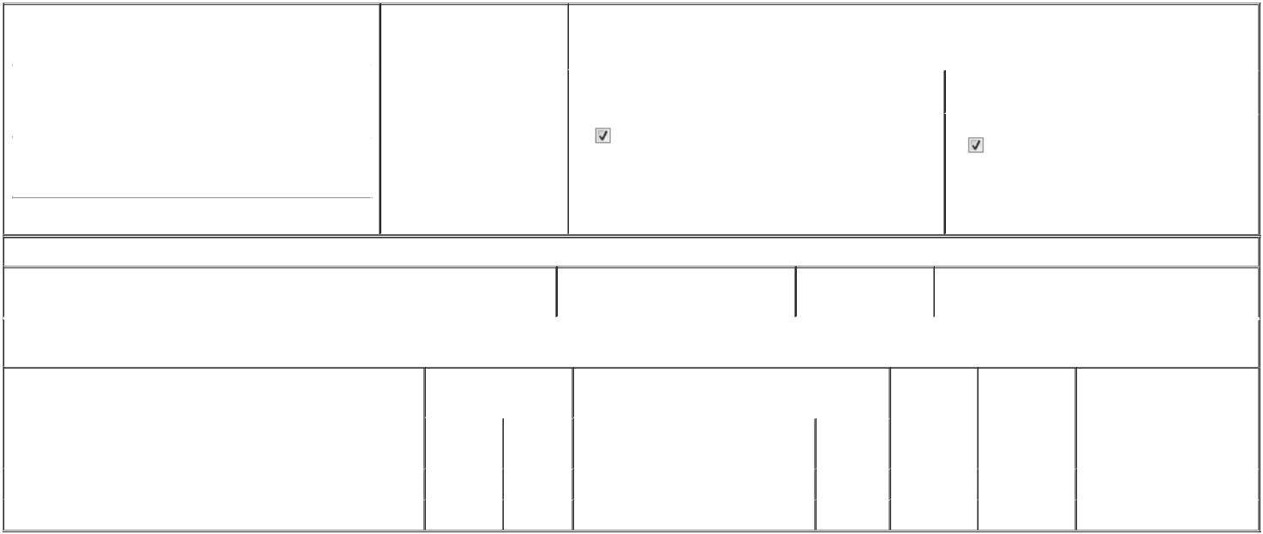

1. Name and Address of Reporting Person* |  |  |  |  |  | 2. Date of Event Requiring
 |  | Kelly Daniel Jude |  |  |  | Statement (Month/Day/Year)
 |  |  |  |  | 05/20/2026
 |  | (Last) | (First) |  | (Middle)
 |  | 2929 ALLEN PKWY, SUITE 2200
(Street)
 |  | HOUSTON | TX |  | 77019

3. |  | Issuer Name and Ticker or Trading Symbol
Talen Energy Corp [ TLN ]
4. |  | Relationship of Reporting Person(s) to Issuer |  |  | 5. | If Amendment, Date of Original Filed (Month/Day/Year)
(Check all applicable)
 |  | Director |  | 10% Owner
 |  |  |  | 10% Owner | 6. | Individual or Joint/Group Filing (Check Applicable Line)
 |  | Officer (give title |  | Other (specify below) | 6. | Individual or Joint/Group Filing (Check Applicable Line)
 |  | below) |  | Other (specify below) |  | Form filed by One Reporting Person
 |  | Gen. Counsel & Corp. Secretary |  |  |  | Form filed by More than One Reporting Person

(City) (State) (Zip)

Table I - Non-Derivative Securities Beneficially Owned

 | 1. Title of Security (Instr. 4) | 2. Amount of Securities Beneficially | 3. Ownership Form: | 4. Nature of Indirect Beneficial Ownership (Instr. 5)
 |  | Owned (Instr. 4) | Direct (D) or Indirect
 |  |  | (I) (Instr. 5)

Table II - Derivative Securities Beneficially Owned

(e.g., puts, calls, warrants, options, convertible securities)

1. Title of Derivative Security (Instr. 4) |  | 2. Date Exercisable and |  | 3. Title and Amount of Securities Underlying |  | 4. | 5. Ownership | 6. Nature of Indirect Beneficial
 |  | Expiration Date |  | Derivative Security (Instr. 4) |  | Conversion | Form: Direct | Ownership (Instr. 5)
 |  | (Month/Day/Year) |  |  |  | or Exercise | (D) or Indirect
 |  |  |  |  |  | Price of | (I) (Instr. 5)
 |  |  |  |  | Amount or | Price of | (I) (Instr. 5)
 |  |  |  |  | Amount or | Derivative
 |  | Date | Expiration | Title | Number of | Security
 |  | Exercisable | Date | Title | Shares
2026 | Restricted Stock Units | (1) | (1) | Common Stock | 2,520 | (2) | D
2026 | Performance-Based Restricted Stock Units | (3) | (3) | Common Stock | 5,880 | (4) | D

Explanation of Responses:

- Represents 840 Restricted Stock Units ("RSUs") that will vest on February 25, 2027, 840 RSUs that will vest on February 25, 2028, and 840 RSUs that will vest on February 25, 2029, in each case subject to the reporting person's continued service.

- Each RSU was issued under the Talen Energy Corporation 2023 Equity Incentive Plan (the "Plan") and represents a contingent right to receive one share of common stock, par value $0.001 ("common stock"), of Talen Energy Corporation (the "Company") or its cash equivalent, as determined at the time of settlement by the Compensation Committee of the Company's Board of Directors (the "Committee") pursuant to the terms of the Plan.

- Represents Performance-Based Restricted Stock Units ("PSUs") that will vest subject to the reporting person's (i) continued service and (ii) achievement of applicable performance goals on February 25, 2029. The number of PSUs that vest can range from 0% to 200% of the target number of PSUs subject to the award, plus, if the maximum performance level is exceeded, an additional number of PSUs in an amount equal to the reporting person's proportionate share among the participating executive officers of 3% of the Company's market capitalization above the maximum performance level. The number of PSUs and shares of common stock in this row represent the maximum level of performance (or 200%).

- Each PSU was issued under the Plan and represents a contingent right to receive one share of common stock or its cash equivalent, as determined at the time of settlement by the Committee pursuant to the terms of the Plan.

Remarks:

Ex. 24.1 - Power of Attorney

 | /s/ Daniel J. Kelly |  | 05/28/2026
 | ** Signature of Reporting Person |  | Date
Reminder: Report on a separate line for each class of securities beneficially owned directly or indirectly.
* If the form is filed by more than one reporting person, see Instruction 5 (b)(v).
** Intentional misstatements or omissions of facts constitute Federal Criminal Violations See 18 U.S.C. 1001 and 15 U.S.C. 78ff(a).
Note: File three copies of this Form, one of which must be manually signed. If space is insufficient, see Instruction 6 for procedure.
Persons who respond to the collection of information contained in this form are not required to respond unless the form displays a currently valid OMB Number.



